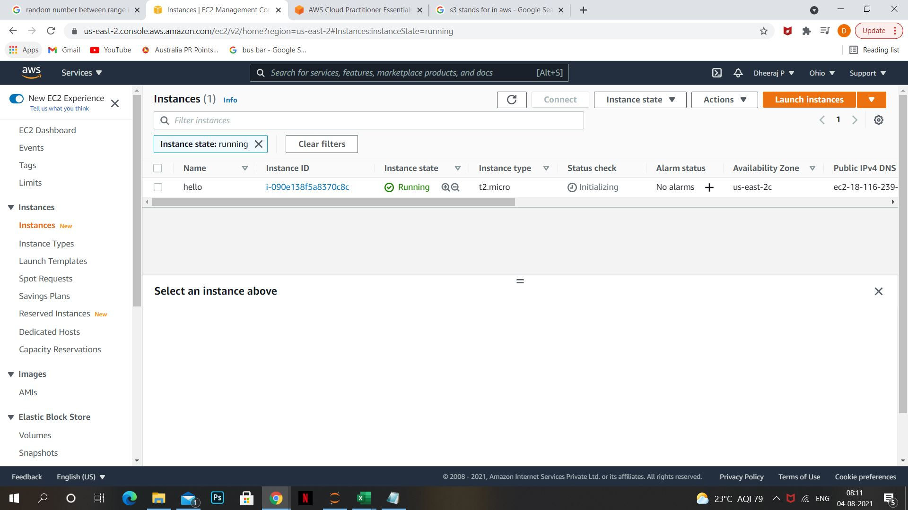

INSTANCE CREATED

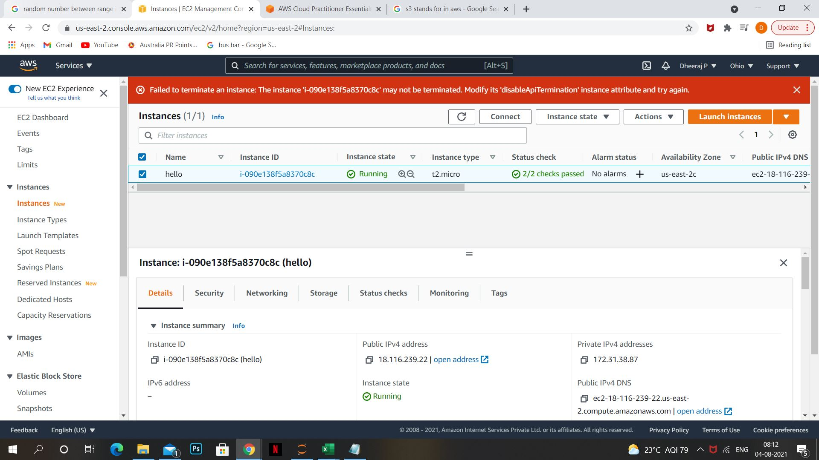

INSTANCE TERMINATION PROTECTION IS ON

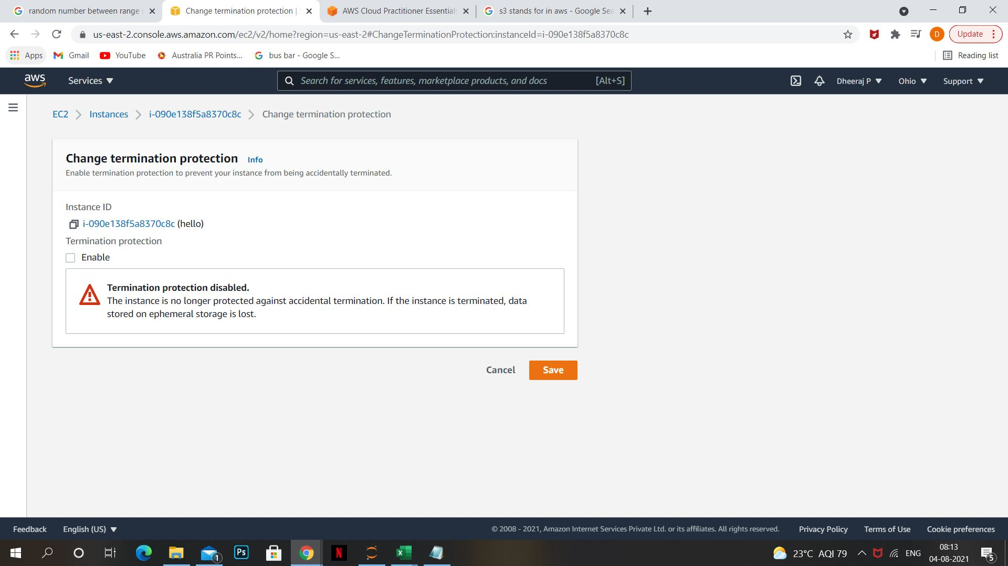

TURNING OF TERMINATION PROTECTION

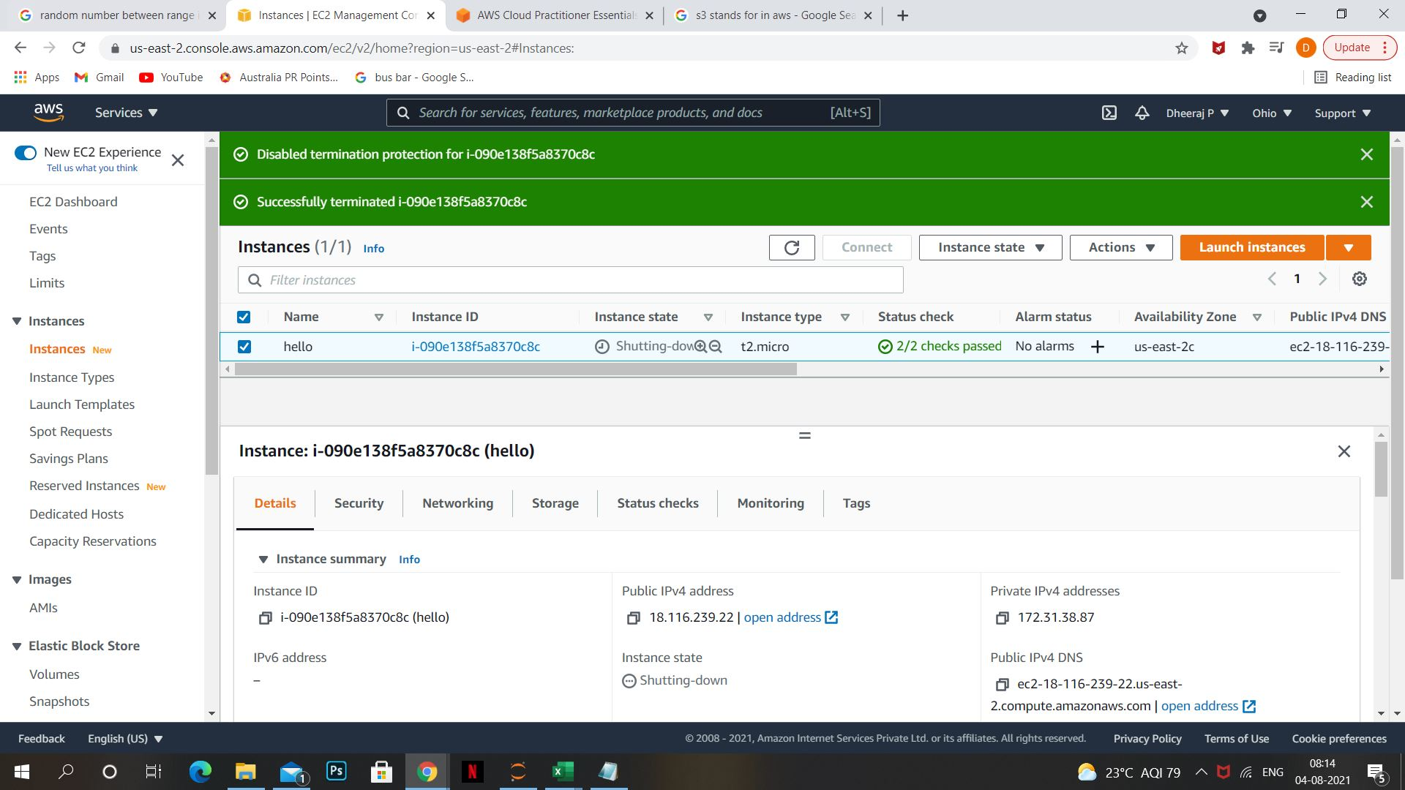

INSTANCE TERMINATED